Koneru Lakshmaiah Education Foundation
(Deemed to be University)

FRESHMAN ENGINEERING DEPARTMENT
A Project Based Lab Report
On
EMI MASTER-LOAN CALCULATOR & PREPAYMENT-SIMULATOR(EMIM-LCPS)

SUBMITTED BY:

N DINESH 2500032556
SAURABH 2500032615
LEELA MANIKUMAR 2500032624

GAUTAM KUMAR 2500032739

UNDER THE GUIDANCE OF
Ms. A Smitha Kranthi
Assistant Professor,CSE.


KL UNIVERSITY
Green fields, Vaddeswaram – 522 502 Guntur Dt., AP, India.

DEPARTMENT OF BASIC ENGINEERING SCIENCES-1



CERTIFICATE

This is to certify that the project based laboratory report entitled
Hospital Patient Record System project submitted by N Dinesh, Sourabh, Leela Manikumar, Gautam kumar bearing RegNo.2500032556, 2500032615, 2500032624, 2500032739 to the Department of Basic Engineering Sciences-1, KL University in partial fulfillment of the requirements for the completion of a project based Laboratory in “Python
Programming”(25SC2007)course in I B Tech II Semester, is a bonafide record of the work carried out by them under my supervision during the academic year 2025 – 2026

PROJECT SUPERVISOR HEAD OF THE DEPARTMENT
Ms. A Smitha Kranthi Dr. D.Haritha

ACKNOWLEDGEMENTS
It is great pleasure for me to express my gratitude to our honorable President Sri. Koneru Satyanarayana, for giving the opportunity and platform with facilities in accomplishing the project based laboratory report. I express sincere gratitude to our Director Dr. A.Jagadeesh for his administration towards our academic growth. I express sincere gratitude to HOD-BES-1 Dr. D.Haritha for her leadership and constant motivation provided in successful completion of our academic semester. I record it as my privilege to deeply thank for providing us the efficient faculty and facilities to make our ideas into reality. I express my sincere thanks to our project supervisor Ms. A Smitha Kranthi for him novel association of ideas, encouragement, appreciation and intellectual zeal which motivated us to venture this project successfully. Finally, it is pleased to acknowledge the indebtedness to all those who devoted themselves directly or indirectly to make this project report success.

N Dinesh 2500032556
Sourabh 2500032615
Leela Manikumar 2500032624
Gautam Kumar 2500032739

ABSTRACT

The EMI Master – Loan Calculator and Prepayment Simulator (EMIM-LCPS) is a Python-based application designed to assist users in efficient loan planning and financial decision-making. The system automates the calculation of Equated Monthly Installments (EMI) by accepting essential inputs such as loan principal amount, annual interest rate, and repayment tenure.
Using standard financial formulas, the application computes the monthly EMI, total repayment amount, and total interest payable over the loan period. In addition to basic EMI calculation, the system includes a prepayment simulation feature that allows users to input an additional payment amount and analyze its impact on the outstanding loan, revised EMI, and overall interest burden.
The project is developed using core programming concepts such as variables, conditional statements, functions, and mathematical computations. It emphasizes accuracy, simplicity, and user-friendliness, making it suitable for beginners and educational purposes. By providing quick and reliable financial insights, the EMIM-LCPS system helps users understand loan dynamics and make informed repayment strategies.
Overall, this project demonstrates the practical application of programming in solving real-world financial problems and highlights the importance of automation in personal finance management.

INDEX
S.NO | TITLE | PAGE NO
1 | Introduction | 6
2 | Aim of the Project | 7
2.1 | Advantages & Disadvantages | 7-8
2.2 | Future Implementation | 8-9
3 | Software & Hardware Details | 9
4 | Flow Chart | 10-11
5 | Algorithm | 12-13
6 | Implementation | 14-19
7 | Integration and System Testing | 19-20
8. | CONCLUSION | 21

INTRODUCTION

In today’s financial environment, loans have become an essential part of personal and business planning. Individuals frequently take loans for purposes such as education, housing, vehicles, and business investments. One of the most important aspects of managing a loan is understanding the Equated Monthly Installment (EMI), which determines the fixed monthly payment required to repay the loan over a specified period. However, manual calculation of EMI and total repayment details can be complex, time-consuming, and prone to errors.
The EMI Master – Loan Calculator and Prepayment Simulator (EMIM-LCPS) is developed to provide a simple, efficient, and automated solution for loan calculation and analysis. The system is built using Python programming and utilizes mathematical formulas to accurately compute EMI, total payment, and total interest based on user inputs such as principal amount, interest rate, and loan tenure.
In addition to basic EMI calculation, the system incorporates a prepayment simulation feature. This feature allows users to enter an additional payment amount and observe how it affects the remaining loan balance, monthly EMI, and total interest. This helps users make better financial decisions by understanding the benefits of early repayment.
The project uses fundamental programming concepts such as variables, control structures, functions, and mathematical operations. It is designed to be user-friendly and efficient, making it suitable for beginners as well as for practical financial analysis. Although the system is a basic implementation, it reflects real-world financial tools used by banks and financial institutions.
Overall, the EMIM-LCPS project demonstrates how programming can be applied to simplify financial calculations, reduce human errors, and improve decision-making in loan management.

AIM

The main aim of the EMI Master – Loan Calculator and Prepayment Simulator (EMIM-LCPS) project is to design and develop a simple, efficient, and user-friendly system using Python to automate loan-related calculations. The project focuses on calculating the Equated Monthly Installment (EMI), total repayment amount, and total interest based on user inputs such as principal amount, interest rate, and loan tenure.
Another objective of this project is to provide a prepayment simulation feature that allows users to analyze the impact of additional payments on their loan. This helps users understand how prepayment can reduce the loan burden and overall interest.
The project also aims to demonstrate the practical application of programming concepts such as variables, control structures, and mathematical computations in solving real-world financial problems. Overall, the system is intended to simplify financial planning and improve decision-making in loan management.
2.1. Advantages:
- Reduces manual effort in calculating EMI and loan details.
- Provides quick and accurate financial calculations.
- Easy to use and user-friendly interface for beginners.
- Helps users understand total payment and interest clearly.
- Includes prepayment simulation to analyze loan reduction.
- Improves financial planning and decision-making.
- Developed using Python, making it simple and efficient.
- Suitable for educational and practical purposes.

Disadvantages
- Limited to basic functionality without advanced financial features.
- Does not include a graphical user interface (GUI).
- Requires manual input; no automation or data storage.
- Lacks security features such as authentication or data protection.
- Not integrated with real-time banking or financial systems.
- Cannot handle multiple users simultaneously.
- No database support for storing previous calculations.
- Limited scalability for large or complex financial applications.

2.2. Future Enhancements
- Develop a graphical user interface (GUI) using Tkinter or PyQt for better user experience.
- Integrate a database system (MySQL/MongoDB) to store user data and loan history.
- Add graphical visualizations such as charts for EMI and interest analysis.
- Implement a web-based version using Flask or Django for remote access.
- Include user authentication and login system for data security.
- Extend the system to support different types of loans (home, car, education).
- Develop a mobile application for easy accessibility.
- Use advanced analytics or AI to provide financial suggestions and insights.

SYSTEM REQUIREMENTS

⮚ SOFTWARE REQUIREMENTS
- Operating System: Windows / Linux / macOS to run the application.
- Programming Language: Python 3.x for developing the system. o IDE/Editor: Visual Studio Code / PyCharm for coding and debugging. o Libraries: NumPy, Pandas, and Matplotlib for analysis and visualization.
- Storage Format: CSV files for saving and retrieving patient records.

➢ HARDWARE REQUIREMENTS
- Processor: Minimum Intel i3 or equivalent for smooth execution.
- RAM: At least 4 GB (8 GB recommended for better performance).
- Storage: Minimum 500 MB free space for project files and data.
- Input Devices: Keyboard and mouse for data entry and control.
- Output Devices: Monitor for display (printer optional for reports).

FLOW CHART
Level-0
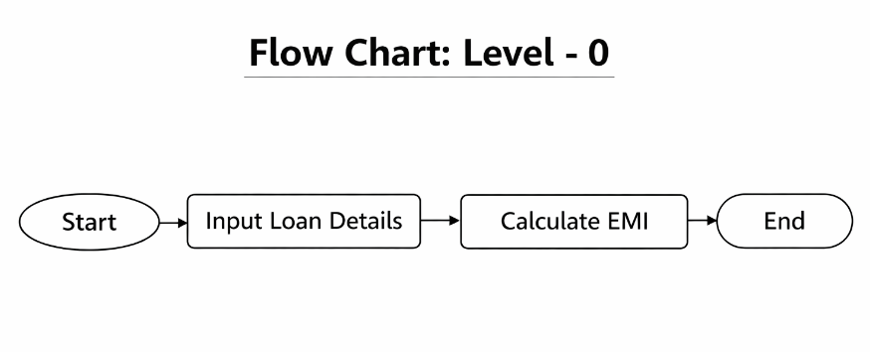

Level-1
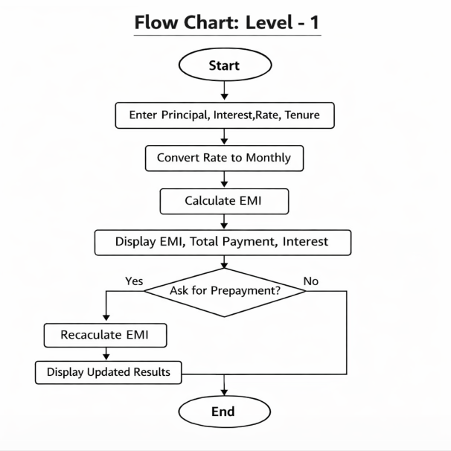

Level-2
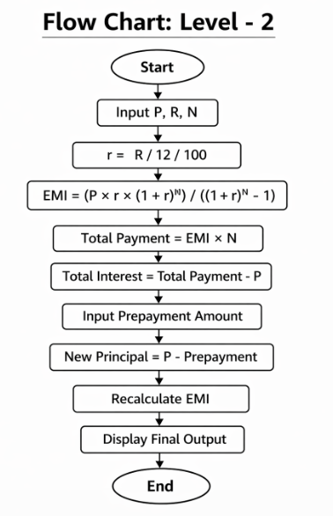

ALGORITHM

MODULE – 1: EMI Calculation
- Step 1: Start
- Step 2: Input loan details (Principal P, Interest Rate R, Tenure N)
- Step 3: Validate inputs (P > 0, R > 0, N > 0)
- Step 4: Convert annual interest rate to monthly rate
r = R / 12 / 100
- Step 5: Apply EMI formula
EMI = (P × r × (1+r)^N) / ((1+r)^N − 1)
- Step 6: Calculate total payment
Total Payment = EMI × N
- Step 7: Calculate total interest
Total Interest = Total Payment − P
- Step 8: Display EMI, total payment, and interest
- Step 9: End

MODULE – 2: Prepayment Simulation
- Step 1: Start
- Step 2: Input prepayment amount
- Step 3: Update principal
New Principal = P − Prepayment
- Step 4: Check condition
If New Principal ≤ 0 → Loan fully paid
- Step 5: Else recalculate EMI using updated principal
- Step 6: Display new EMI and updated loan details
- Step 7: End

MODULE – 3: Output Display
- Step 1: Start
- Step 2: Display loan details (P, R, N)
- Step 3: Display calculated EMI
- Step 4: Display total payment and total interest
- Step 5: Display updated EMI after prepayment
- Step 6: End

IMPLEMENTATION

class LoanCalculator:
def __init__(self):
self.P = 0
self.R = 0
self.N = 0
self.r = 0

def get_input(self):
try:
self.P = float(input("Enter Loan Amount: "))
self.R = float(input("Enter Annual Interest Rate (%): "))
self.N = int(input("Enter Loan Tenure (months): "))

if self.P <= 0 or self.R <= 0 or self.N <= 0:
print("Invalid input! Values must be greater than 0.")
return False

self.r = self.R / 12 / 100
return True
except:
print("Invalid input format!")
return False

def calculate_emi(self):
emi = (self.P * self.r * (1 + self.r) ** self.N) / ((1 + self.r) ** self.N - 1)
return emi

def calculate_total_payment(self, emi):
return emi * self.N

def calculate_total_interest(self, total_payment):
return total_payment - self.P

def display_details(self, emi, total_payment, total_interest):
print("\n----- LOAN DETAILS -----")
print("Loan Amount:", self.P)
print("Interest Rate:", self.R)
print("Tenure:", self.N)
print("-------------------------")
print("Monthly EMI:", round(emi, 2))
print("Total Payment:", round(total_payment, 2))
print("Total Interest:", round(total_interest, 2))

def prepayment(self):
try:
amount = float(input("\nEnter Prepayment Amount: "))
if amount <= 0:
print("Invalid amount!")
return

self.P = self.P - amount

if self.P <= 0:
print("Loan fully paid!")
else:
new_emi = self.calculate_emi()
print("Updated Principal:", self.P)
print("New EMI:", round(new_emi, 2))
except:
print("Invalid input!")

def menu(self):
while True:
print("\n====== EMI MASTER MENU ======")
print("1. Enter Loan Details")
print("2. Calculate EMI")
print("3. Prepayment Simulation")
print("4. Exit")

choice = input("Enter your choice: ")

if choice == "1":
if self.get_input():
print("Details saved successfully!")

elif choice == "2":
if self.P == 0:
print("Enter loan details first!")
else:
emi = self.calculate_emi()
total_payment = self.calculate_total_payment(emi)
total_interest = self.calculate_total_interest(total_payment)
self.display_details(emi, total_payment, total_interest)

elif choice == "3":
if self.P == 0:
print("Enter loan details first!")
else:
self.prepayment()

elif choice == "4":
print("Exiting program...")
break

else:
print("Invalid choice!")

# Run Program
app = LoanCalculator()
app.menu()

INTEGRATION AND SYSTEM TESTING
OUTPUTS Screen Shots:
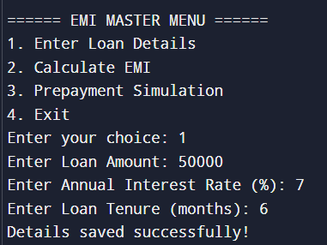
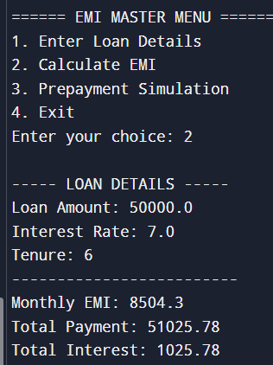
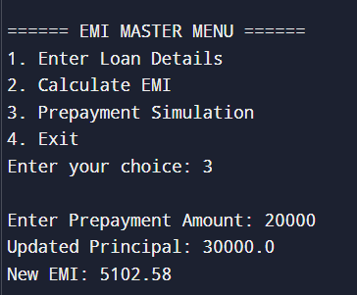

CONCLUSION
The EMI Master – Loan Calculator and Prepayment Simulator (EMIM-LCPS) successfully demonstrates the use of Python programming in solving real-world financial problems. The system efficiently calculates the Equated Monthly Installment (EMI), total repayment amount, and total interest based on user inputs such as principal, interest rate, and tenure.
The inclusion of the prepayment simulation feature enhances the usefulness of the system by allowing users to analyze how additional payments can reduce their loan burden and interest. This helps in better financial planning and decision-making.
The project is implemented using basic programming concepts and follows a structured approach, making it easy to understand and use. Although it is a simple application, it provides a strong foundation for developing more advanced financial systems in the future.
Overall, the EMIM-LCPS project highlights the importance of automation in financial calculations and shows how programming can be effectively applied to improve accuracy, efficiency, and user convenience.

